Skyline Small Molecule Targets

The Skyline Targeted Proteomics Environment provides informative visual displays of the raw mass spectrometer data you import into your Skyline documents. Originally developed for proteomics use, Skyline has been extended to work with generalized small molecules. There are many tutorials available that will help you use Skyline for various types of analysis (SRM, MS1 Filtering, DIA, Targeted MS/MS etc). This tutorial concentrates on the differences in using Skyline for targeting small molecules.

In this tutorial, you will build an MRM assay for a group of Methionine-pathway compounds.

Skyline aims to provide a vendor-neutral platform for targeted quantitative mass spec research. It can import raw data from the instrument vendors Agilent, SCIEX, Bruker, Shimadzu, Thermo-Scientific and Waters. The ability to import data across various instrument platforms greatly facilitates cross-instrument comparisons and large multi-site studies. This remains equally true in using it to target small molecules, as it has been for years in the field of proteomics.

# Getting Started

To start this tutorial, download the following ZIP file:

<https://skyline.gs.washington.edu/tutorials/SmallMolecule_3_6.zip>

Extract the files in it to a folder on your computer, like:

C:\Users\bspratt\Documents

This will create a new folder:

C:\Users\bspratt\Documents\SmallMolecule

It will contain all the files necessary for this tutorial. Now start Skyline, and create a new empty document.

# Importing a Small Molecule Transition List into a Skyline Document

The easiest way to get a small molecule transition list into a Skyline document is to start with an empty document and use the **Edit > Insert > Transition List** menu item. [Note: the **File > Import >Transition List** menu item also works, so long as your data has column headers which are recognized by Skyline. For a list of recognized column names, press the “Help” button in the **Edit > Insert > Transition List** window.]

At a minimum, Skyline needs to know the charge state and either the ion formula or m/z for each precursor and product. If no product ion information is present in a transition list, it is assumed to be a list of precursor targets. Repeated precursor information with different product information is assumed to indicate multiple transitions of a single precursor, just as with peptides.

### A note on ion formulas and adduct descriptions

In proteomics applications Skyline can safely assume ionization by protonation. So, all that is needed to describe a charged peptide is its sequence and charge state. Skyline just adds protons (hydrogen minus an electron) to the underlying chemical formula as needed. For generalized small molecules, however, ionization can be achieved by almost any means (sodium gain, hydrogen loss, etc.). These kind of ionization modes can be specified in Skyline using adduct descriptions of the style used at <http://fiehnlab.ucdavis.edu/staff/kind/Metabolomics/MS-Adduct-Calculator/>, e.g “[M+Na]”, “[M-2H]” etc. Note: It is also possible to describe your transition list completely in terms of m/z values for both precursors and products, but without a chemical formula Skyline cannot provide isotopic distributions so formula and adduct descriptions are preferred.

## Transition list insert

To begin creating your first Skyline document that targets small molecules, do the following:

* Locate the “SMTutorial_TransitionList.csv” file and open it in Excel.
* On the Skyline **Edit** menu, choose **Insert** and click **Transition List**.

Skyline will show the **Insert** form, which may start out looking like this:

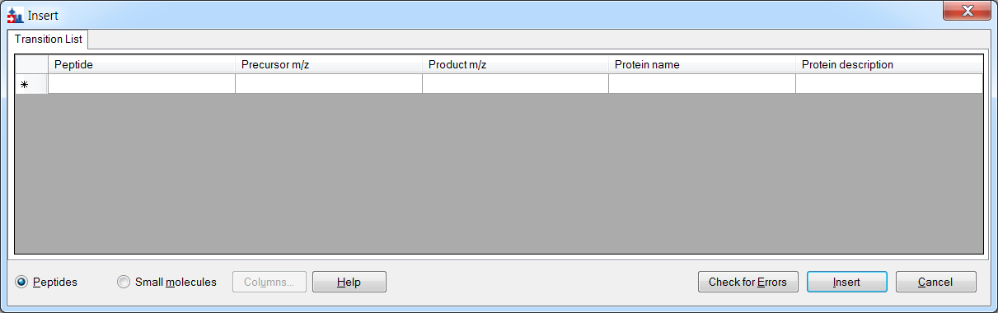

If it does, you can change it to accept small molecule fields by doing the following:

* Click the **Small molecules** option at the bottom of the form.

The form should now look like this:

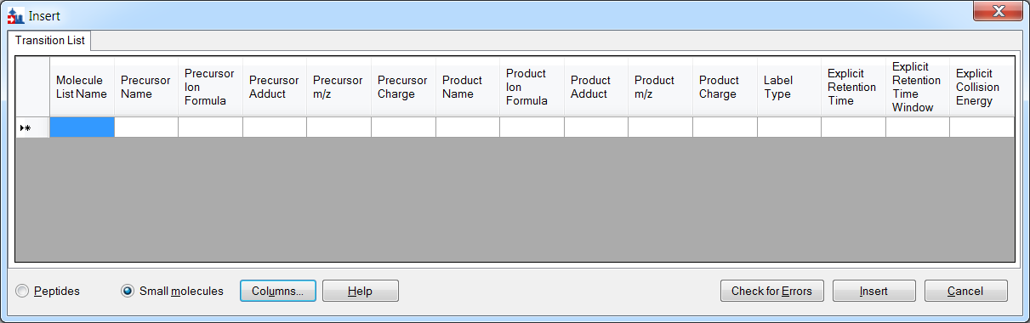

In the transition list spreadsheet, you should find the following values:

|  |  |  |  |  |  |  |  |  |  |
| --- | --- | --- | --- | --- | --- | --- | --- | --- | --- |
| Molecule List Name | Precursor Name | Precursor Formula | Precursor Adduct | Precursor Charge | Precursor RT | Precursor CE | Product m/z | Product Charge | Label |
| Amino Acid | Methionine | C5H11NO2S | [M+H] | 1 | 2.5 | 15 | 104.07 | 1 |  |
| Amino Acid | Methionine | C5H8H'3NO2S | [M+H] | 1 | 2.5 | 15 | 107.09 | 1 | heavy |
| Amino Acid | Isoleucine | C6H13NO2 | [M+H] | 1 | 2.9 | 15 | 86.096 | 1 |  |
| Amino Acid | Leucine | C6H13NO2 | [M+H] | 1 | 3 | 15 | 86.096 | 1 |  |
| Amino Acid | Leucine | C6H10H'3NO2 | [M+H] | 1 | 3 | 15 | 89.1 | 1 | heavy |
| Amino Acid | Phenylalanine | C9H11NO2 | [M+H] | 1 | 3.1 | 15 | 120.08 | 1 |  |
| Amino Acid | Phenylalanine | C9H11NO2 | [M6C13+H] | 1 | 3.1 | 15 | 126.11 | 1 | heavy |
| Amino Acid | Arginine | C6H14N4O2 | [M+H] | 1 | 2.01 | 15 | 116.07 | 1 |  |
| Amino Acid | Arginine | C1C'5H14N4O2 | [M+H] | 1 | 2.01 | 15 | 121.11 | 1 | heavy |
| Amino Acid | Ornithine | C5H12N2O2 | [M+H] | 1 | 0.85 | 15 | 70.07 | 1 |  |
| Amino Acid | Ornithine | C5H12N2O2 | [M+H] | 1 | 0.85 | 15 | 116.07 | 1 |  |
| Amino Acid | Ornithine | C5H10H'2N2O2 | [M+H] | 1 | 0.85 | 15 | 72.07 | 1 | heavy |
| Amino Acid | Ornithine | C5H10H'2N2O2 | [M+H] | 1 | 0.85 | 15 | 118.07 | 1 | heavy |
| Organic Acid | creatine | C4H9N3O2 | [M+H] | 1 | 1.1 | 15 | 90.06 | 1 |  |
| Organic Acid | creatine | C4H6H'3N3O2 | [M+H] | 1 | 1.1 | 15 | 93.06 | 1 | heavy |
| 5'-methylthioadenosine | MTA | C11H15N5O3S | [M+H] | 1 | 3.4 | 15 | 136.1 | 1 |  |
| 5'-methylthioadenosine | MTA | C11H12H'3N5O3S | [M+H] | 1 | 3.4 | 15 | 136.1 | 1 | heavy |
| S-adenosyl methionine | SAM | C15H22N6O5S | [M+H] | 1 | 2.9 | 15 | 250.11 | 1 |  |
| S-Adenosyl homocysteine | SAH | C14H20N6O5S | [M+H] | 1 | 2.9 | 15 | 136.08 | 1 |  |
| Polyamine | Spermidine | C7H19N3[M+H] |  | 1 | 3.3 | 15 | 129.15 | 1 |  |
| Polyamine | Spermine | C10H26N4 | [M+H] | 1 | 3.5 | 15 | 112.112 | 1 |  |

### Further notes on ion formulas and adduct descriptions

In this example, there are some light-heavy isotope label pairs, e.g. Methionine and d3-Methionine. In the transition list they are described as **C5H11NO2S [M+H]** and **C5H8H'3NO2S [M+H]**, but using the language of adduct descriptions they could also have been described as **C5H11NO2S [M+H]** and **C5H11NO2S [M3H2+H].** You can see an example of this in the Phenylalanine heavy-light pair: the formulas are the same but the heavy adduct description specifies that 6 carbons are replaced with C13. Note that the Adduct column is optional: as in the example of Spermidine, the adduct can be given as part of the ion formula. Note also that the Precursor Charge column is not actually needed: the charge states can be inferred from the adduct descriptions. The label column is also not strictly needed: the heavy label can be inferred from the precursor ion formula and/or adduct.

You can see that there are some extra column headers in the **Insert** form, and the column order is not the same in the form as in the spreadsheet. Both issues are easy to correct:

* Click the **Columns** button and uncheck the columns that do not appear in the spreadsheet.

This should result in a column picking menu like the one shown below:

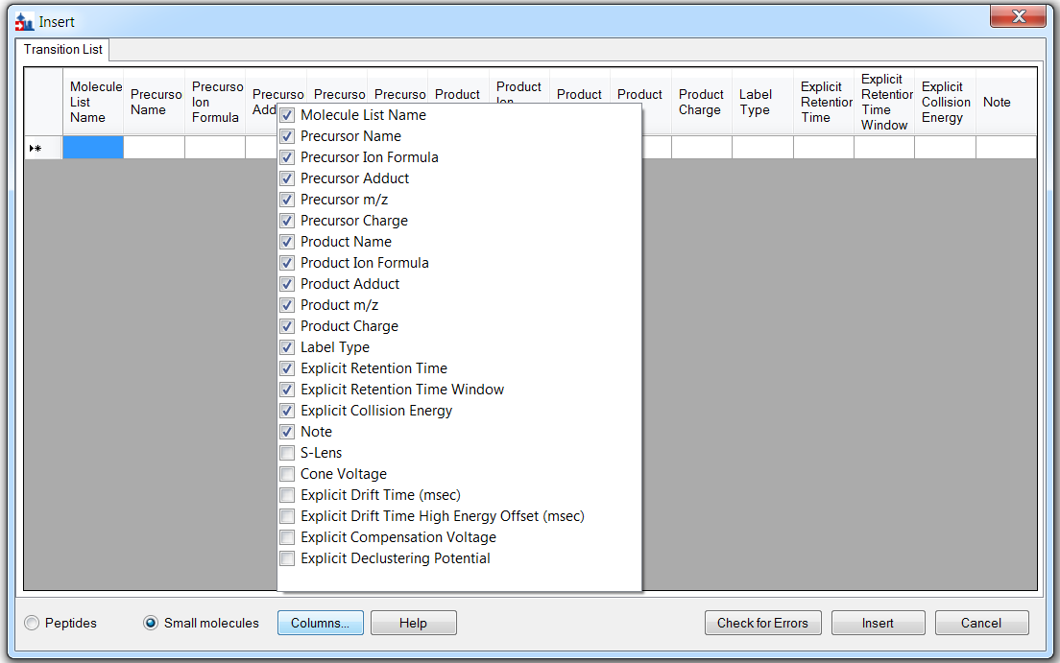

Next do the following to reorder the columns in the **Insert** form:

* Click and drag each column header you want to move to the order matching the spreadsheet. Once you have selected and arranged your columns, the insert form should now appear as shown below:

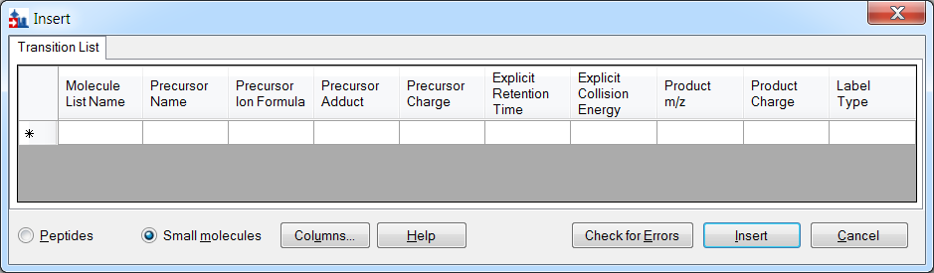

To add the transitions specified in the spreadsheet, do the following:

* Select the contents of the spreadsheet, excluding the first row containing the headers.
* Click the **Copy** button on the toolbar.
* Switch back to Skyline.
* Press Ctrl-V on your keyboard to paste.
* Click the **Check for Errors** button.

NOTE: If you accidentally copied the header row or got the column order wrong, then you will see an error at this point. Otherwise, the **Insert** form should look like this:

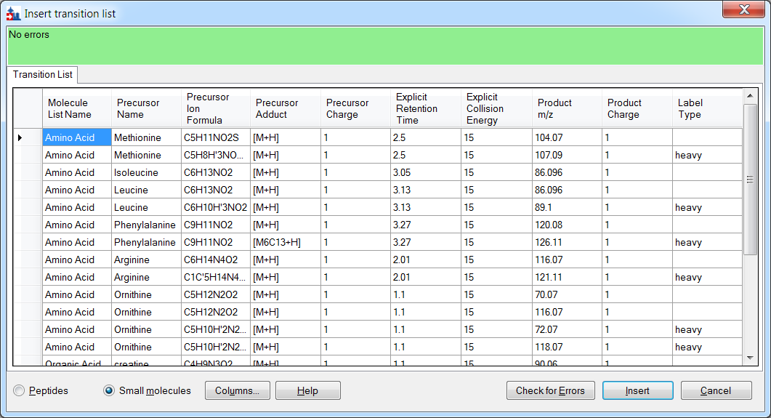

* Click the **Insert** button.

Your Skyline window should now look like:

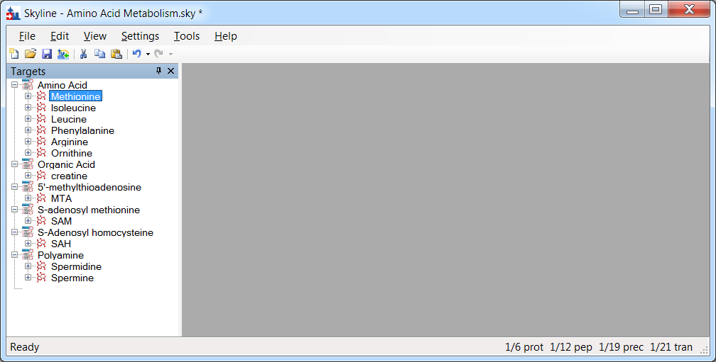

At this point, either a native instrument method, precursor isolation list (for PRM) or transition list (for SRM) can be exported. For more details on how to perform this step, please see the [Targeted Method Editing](https://skyline.gs.washington.edu/labkey/wiki/home/software/Skyline/page.view?name=tutorial_method_edit), [Existing and Quantitative Experiments](https://skyline.gs.washington.edu/labkey/wiki/home/software/Skyline/page.view?name=tutorial_existing_quant) or [Targeted MS/MS (PRM) tutorial](https://skyline.gs.washington.edu/labkey/wiki/home/software/Skyline/page.view?name=tutorial_targeted_msms).

## Importing mass spectrometer runs

In this tutorial, you will simply import raw data from a Waters Xevo TQS instrument acquired using a MassLynx instrument method exported by Skyline. To do this now, perform the following steps.

* On the **File** menu, click **Save**. (Ctrl-S)
* Save this document as “Amino Acid Metabolism.sky” in the tutorial folder you created.
* On the **File** menu, select **Import** and click on **Results**.
* In the **Import Results** form, choose to import single-injection replicates. For best performance, be sure to select “Many” in the “Files to import simultaneously” control at the bottom of the form. Now click the **OK** button.
* Select all 18 raw data folders in the tutorial folder by clicking the first listed and then holding down the Shift key and clicking the last.

The **Import Results Files** form should look like:

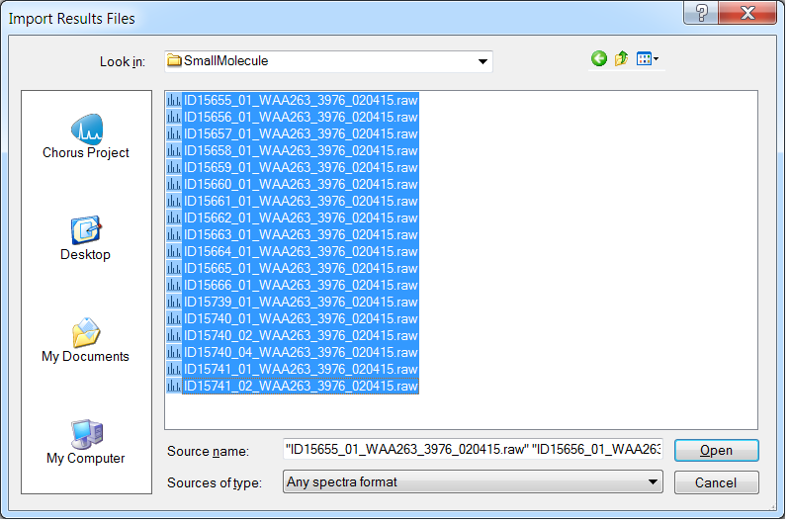

* Click the **Open** button.
* Click the **Do not remove** button when asked about removing the common prefix.

The files are a metabolite extract of cancer cell lines under specific amino acid deprivation conditions, where cells were deprived of either the amino acid Methionine, or Arginine, or both, for a period of 3 hours versus control (all amino acids).1

Filenames and Conditions:

ID15739_01_WAA263_3976_020415 – double blank

ID15740_01_WAA263_3976_020415 – Extraction Blank (contains SIL standards)

ID15740_02_WAA263_3976_020415 – Extraction Blank (contains SIL standards)

ID15740_04_WAA263_3976_020415 – Extraction Blank (contains SIL standards)

ID15655_01_WAA263_3976_020415 – All AA Sample 1

ID15656_01_WAA263_3976_020415 – All AA Sample 2

ID15657_01_WAA263_3976_020415 – All AA Sample 3

ID15658_01_WAA263_3976_020415 – Minus Met Sample 1

ID15659_01_WAA263_3976_020415 – Minus Met Sample 2

ID15660_01_WAA263_3976_020415 – Minus Met Sample 3

ID15661_01_WAA263_3976_020415 – Minus Arg Sample 1

ID15662_01_WAA263_3976_020415 – Minus Arg Sample 2

ID15663_01_WAA263_3976_020415 – Minus Arg Sample 3

ID15664_01_WAA263_3976_020415 – Minus Arg, Minus Met Sample 1

ID15665_01_WAA263_3976_020415 – Minus Arg, Minus Met Sample 2

ID15666_01_WAA263_3976_020415 – Minus Arg, Minus Met Sample 3

ID15741_01_WAA263_3976_020415 – Pooled QC Sample 1

ID15741_02_WAA263_3976_020415 – Pooled QC Sample 2

The files should import within a matter of seconds, leaving your Skyline window looking like:

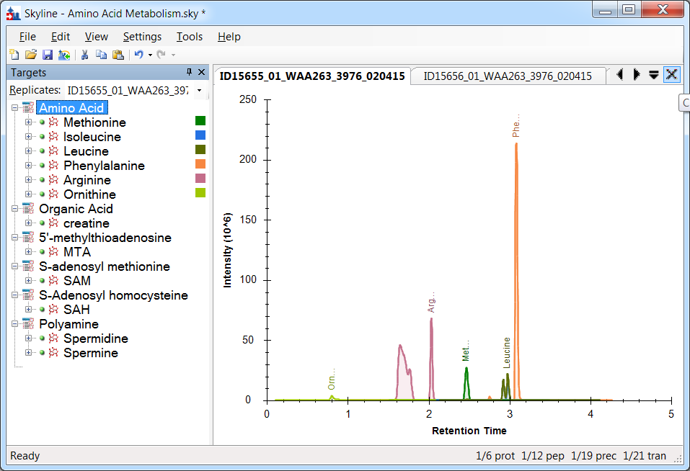

To take advantage of the Skyline summary graphs for viewing individual targets, do the following:

* On the **View** menu, choose **Peak Areas** and click **Replicate Comparison**.
* On the **View** menu, choose **Retention Times** and click **Peak Areas**.
* Click and drag these views to dock them above the chromatogram graphs.
* Select the first target “Methionine” in the **Targets** view.

The Skyline window should now look something like this:

# 

# Conclusion

In this tutorial, you have learned how to create a Skyline document that targets small molecules specified as precursor ion chemical formulas and adducts, and product ion m/z values. You imported a multi-replicate data set collected by a metabolomics researcher, and saw how many existing Skyline features created initially for targeted proteomics use can now be applied to small molecule data. Small molecule support is still a relatively new feature area for Skyline. As such, you can expect it to continue improving rapidly.

# Bibliography

1. Tang, X. *et al.* Comprehensive Profiling of Amino Acid Response Uncovers Unique Methionine-Deprived Response Dependent on Intact Creatine Biosynthesis. *PLoS Genet* **11,** e1005158 (2015).